Pricing Tools 2/19/07

One of the things that we frequently hear relates to a “fear” of moving from manual pricing to pricing based upon criteria within Advantzware – or as one perspective client put it:
“How can we help to assure the profitable growth of our business, especially in light of the forthcoming potential retirements of key players in sales and pricing?”

We truly believe that we do an excellent job of translating your existing business strategies into the costing and pricing tools that are built into Advantzware. We would recommend that we budget specific analysis and training hours to specifically address this need. To accomplish this we may suggest additional on-site services to analyze cost and build the historic “mind set” into Advantzware. The goal would be to:
- Validate all direct cost rates and load them in the system (board, other materials, labor, delivery)
- Develop realistic machine hour rates
- Work with you on an annual business budget to determine variable and fixed overheads that need to be recovered
- Run estimates on multiple historic items and determine the gross and net margins in Advantzware by customer, product type and order size. This would be a time consuming process, but laying the results out in a spread sheet would allow us to formulate your “pricing logic”.
- Build this “pricing logic” into Advantzware. The Pricing File will default a price into the estimate based upon a predetermined set of criteria. This criteria is built by customer, and then by style / category (in this case, Die Cut and Point of Purchase). You can then establish a desired profit level as either a % over direct cost (Gross), a % over total cost (Net) or a % over board cost. The mark ups are also in up to square footage ranges. The objective would be to hone this as close as possible to the existing mind set in pricing and then tweak it over time by periodically pricing items manually and then comparing them to the suggested price in our estimating system.

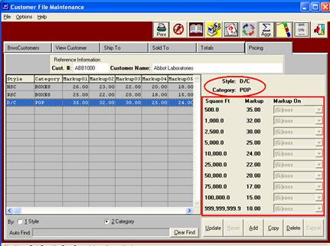

- Consistency within accounts: Over time we would also suggest that our clients view how they have priced similar items to assure that there is consistency, especially within a customer. This query allows you to do a “similar item” look up (in this case, all RSC’s within a size range).
